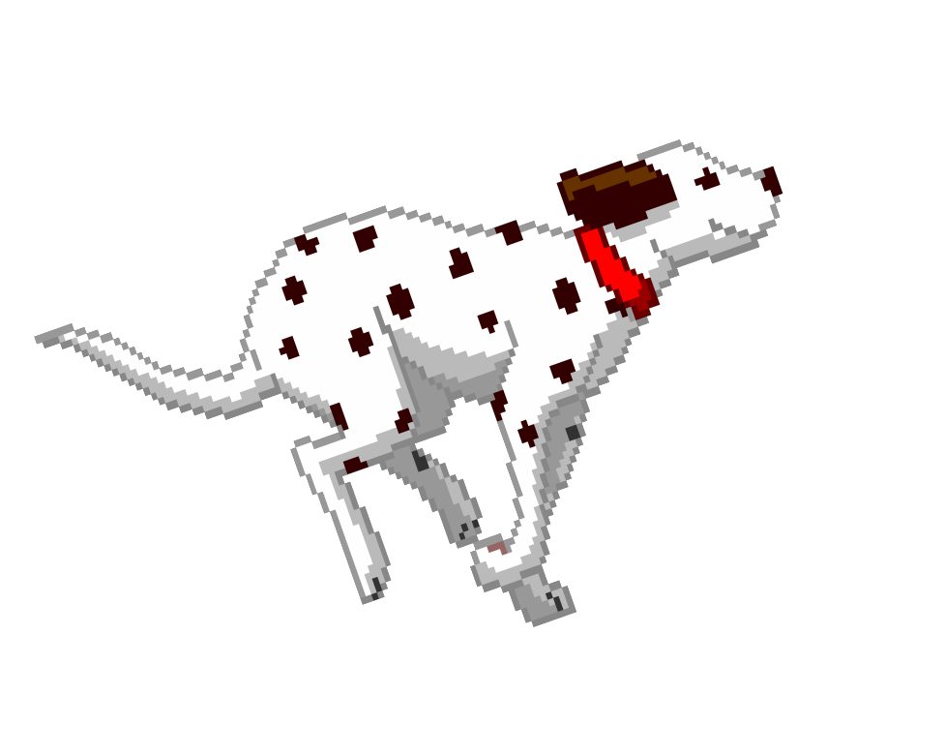Pooch Plunge
September 4, 2016
Tomah Aquatic Center, 411 E Holton St, Tomah WI
Please print and complete this Waiver and bring it with you on September 4, 2016

Waiver
RELEASE AND INDEMNITY TO:
The Participant set forth below.
We understand that you (the "Participant") would like to participate in the Pooch Plunge event (the "Event") to be held on Sunday, September 4, 2016. Please know that the City of Tomah, Chasing Daylight Animal Shelter (together, the "Sponsors") are unable to and do not
accept any liability or responsibility whatsoever for any damages or injuries sustained by you or your dog while attending the Event, whether occasioned by the conduct of other dogs, their owners or otherwise. By signing below, and in consideration of our allowing you and your dog to attend and participate in the Event, you hereby: (a) release the Sponsors from any liability whatsoever in respect of any damages or injuries which you or your dog may suffer while attending or participating in the Event; and, (b) agree to indemnify and hold the Sponsors harmless from all claims, damages or injuries arising out of any act occasioned by you or your pet. Please know that the Sponsors reserve the right to remove any persons or dogs from the Event for any behavior, which the Sponsors may, in their discretion, deem inappropriate. Without in any way limiting your release and indemnification of the Sponsors as provided for above, by signing below you, additionally and specifically, agree as follows:

I, , hereby release the Sponsors from (and acknowledge and agree that the Sponsors accept no responsibility whatsoever for) any and all claims I may have for any damages or injuries resulting from or during my and/or my dog's participation in the Event, however occasioned, including, without limitation, if occasioned by the conduct or actions of any persons or dogs who may also be participating in or organizing the Event.

I, , accept full responsibility for my conduct and that of my dog at all times and hereby agree to indemnify and hold the Sponsors harmless, from any or all claims, damages or injuries which they may suffer or incur, whether directly or indirectly, as a result of my or my dog's actions and/or participation in the Event. This includes any liability for damages suffered by others because of any conduct or action by my dog or myself.
We hope you enjoy the Event.

Sincerely,
City of Tomah and Chasing Daylight Animal Shelter Inc.

Signature of Participant : Date:

Paid $15.00 Fee

Name of Participant:(First) (Last)

Participant's Address:

Participant's Phone No:

Vaccination Proof required. Name of Veterinarian: Rabies tag #:

Dog License #:

Dog's Name:

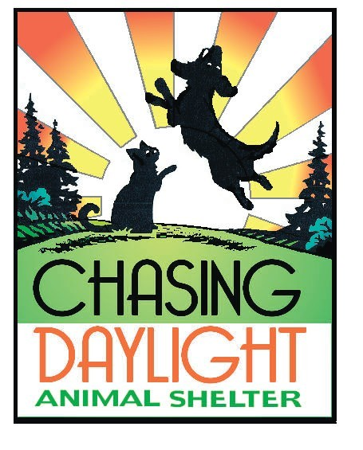Age: Breed: Gender: M or F
Neutered/Spayed: Y or N (Altered dogs only allowed at this event)

